[Note: To complete this template, replace the bracketed text with your own content. Remove this note before you submit your outline.]

Report: Housing Price Prediction Model for D. M. Pan National Real Estate Company
[Your Name]
Southern New Hampshire University

Introduction
This study aims at studying the median housing prices, which is based on the footage. In achieving this, the 2019 data is utilized. The study will be useful in predicting the Median housing cost/Prices with the bases on the square footage. The report tries to answer the question on whether there is any relation between the square footage and the median housing prices so that the real estate company can utilize their relationship for the purposes of predicting future trend of change in relation to the two key variables.

Data Collection
Using the sampled data from the selected 50 counties, in the East North Central Region, the random samples is always selected using the randomly sampled numbers, which is generated using, excel. The median listing price in the study is the response variable and the predictor in this study is the median square feet variable.
Scatterplot:

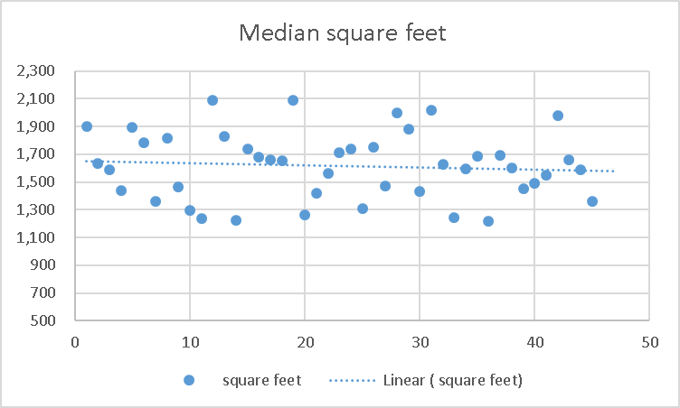
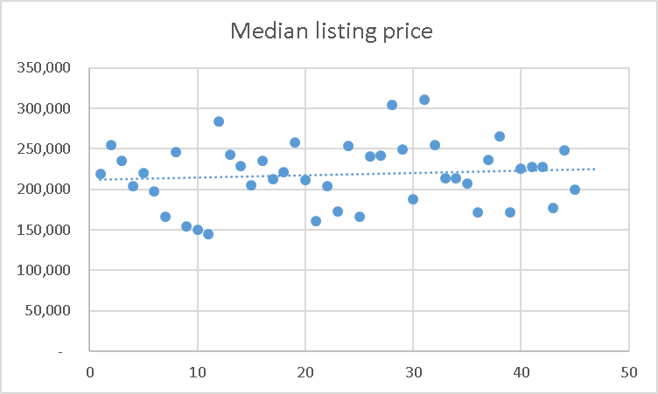

Data Analysis
Listing price Histogram

Square Feet Histogram

Summary statistics:
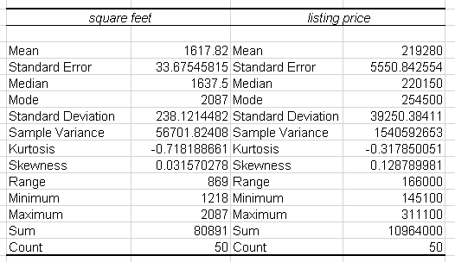
Interpret the graphs and statistics.
Considering the various shapes of the curves, both two variables have a mean that is less than the median. All the tow graphs indicate a peak at within their centers thus indicating the positive relationship of the variables. The summary statistics above indicates that, the standard deviation of one variable (Listing price) to be larger. In comparison with the National Data, the standard deviation for the Square feet sample variable tend to be more compared to that in the national data but its media is much smaller than that of the National data. To consider the kurtosis of data for the median listing cost/ price in the national data, it show the leptokurtic curve although for the sampled data, we are in apposition to see the platokurtic curve. I consider the data to have a representation of the national market in terms of housing, and this is because, the sampled data has not big difference with the sampled data nationally in the 2019 National Data.

The Regression Model

Based on our graph, this indicates that, indeed regression model can be utilized in the data, although this may not have that much close estimation, it can still be utilized to have tentative estimates on the sampled data. If we consider removing all the outliers for a much better estimation, it will be evident that, between the two variables there is a positive correlation.

Considering the excel data, I utilized the excel formula to determine the correlation coefficient of the two variables (listing price and the square feet) shown in the scatterplot.
R=0.63974152, this indicates a moderate degree of the positive correlation as represented in the scatter graph.

The Line of Best Fit
Regression equation of the drawn line of best fine is as shown below;

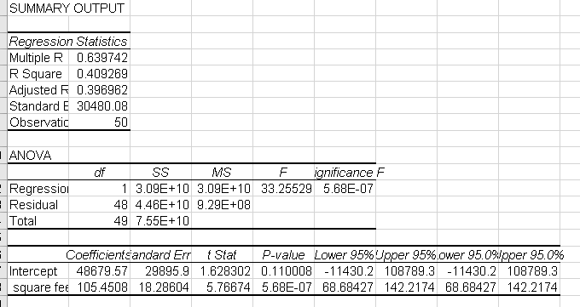

Use regression equation to make predictions:
The regression equation for this line of best fit of the graph remains to be in the form of y=mx+b or y=b+mx,
Basically this can be represented by the equation y=105.4508x+48679.57
In this case, the slope of the equation is 105.4508 and the intercept of the equation is 48679.57. The strength of the equation is 0.4093 and the coefficient of the determination is obtained as 40.93%. On the other hand, we consider the strength of the regression equation as 40.93%

Conclusions
In summation, the results were just as we had expected. The research indicated that, it is possible to predict the values basing on the square feet in various household. Outliers are seen though they are not many and this might be because of the variation in various states within the region. If we were to concentrate on certain states, then the results would be more precise and correct. The only way of improving the results will be to bring homogeneity to the sampled data in certain regions. The question that would be arising from the research and might be interesting is that, if one more variable such as location can bring any variation.

